

**Coursework**

**Faculty:** Mathematics and Informatics

**Specialty:** Informatics

**Discipline:** Databases

**Produced: Nikola** Atanasov Hadzhiev

**Subject:** Book Library Database

**Lecturer in discipline**:

Assc. Tsvetanka Lyubomirova Georgieva-Trifonova MD

**Faculty No:**  2009012027

Content

1. Description of the subject area 2

2. ER model based on 3

3 . Database relation model 4

4 . Realization of the relationship model of the database 5

5. Create queries 6

6. Create the necessary : 7

7. Future work 8

## 1. Description of the subject matter

Introducing an SQL database into the library activity provides easier book store management and faster access to the necessary information. Working with readers is facilitated and accelerated. The database will assist and facilitate staff in searching, finding and entering certain information.

The database stores information about a library of books (name, author, book type, book year, number of pages, rental price, cover type and color), reader's card (name and surname of the particular person, personal identification number, city, address and phone number).

## 2. ER model based on

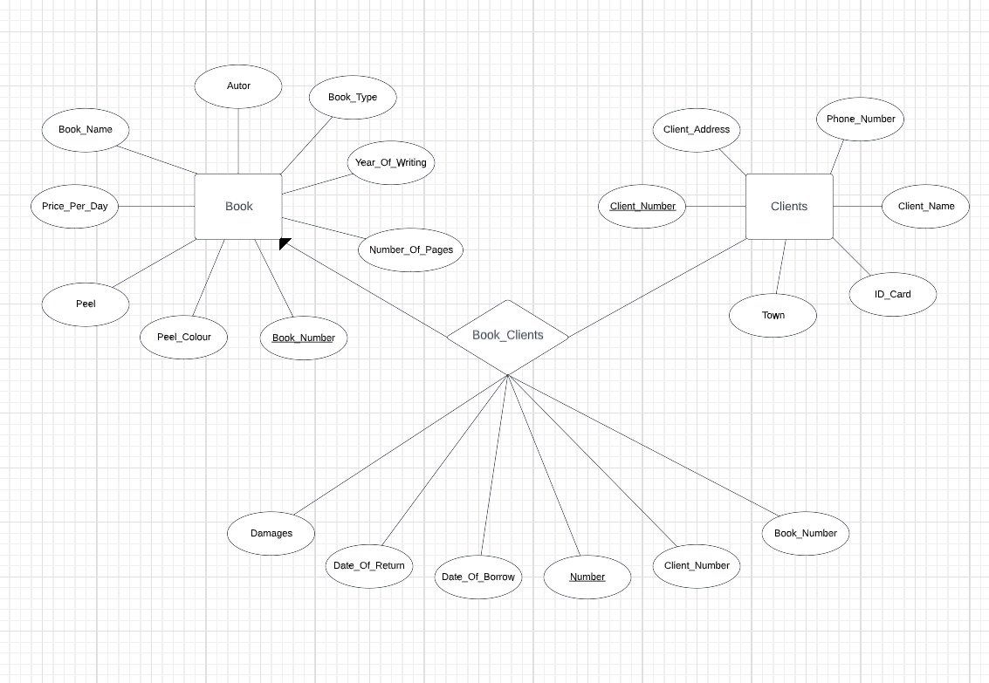

The objects in the database are: book, clients, and book_clients.

The *book object* has *Book_Number* attributes – primary key, *Book_Name* – book name, *Autor* – a tuesday, *Book_Type* – book type, *Year_Of_Writing* – year of writing, *Number_Of_Pages* – number of pages,  *Price_Per_Day* – price per day, *Peel* – cover*, Peel_Color* – cover color.

The *client object* has *Client_Number* attributes – primary key, *Clients_Name* – *client name*, ID_Card – personal number, *Town* – city, *Client_Address* – address, *Phone_Number* – phone number.

Thereare *book_clients number attributes* –  *primary* key, *Book_Number* – primary key, *Client_Number* – primary key, *Date_Of_Borrow* – pickup date, *Date_Of_Return* – return date, *Damages* – damage.

The  *book* and *clients* are connected via a "many-to-one" link  *via a book_clients* link (one book can be occupied by one user and one user may have occupied several bookies).

## 3 . Relational model of the database

The database consists of 3 tables: *Books*, *Clients* and *Book_clients*.

The  *Books table* consists of 9 columns: *Book_Number*–  *primary key of type INT*, *Book_Name* of  *type VARCHAR(30), Author of type VARCHAR(30)*, *Book_Type of type VARCHAR(30), Year_Of_Writing* of  *type INT* *, Number_Of_Pages int type, Price_Per_Day of type MONEY, Peel of type VARCHAR(20)*  *and Peel_Colour of type VARCHAR(20)*.

The  *Clients* table consists of 5 columns: *Client_Number* – primary key o t *type INT*, *Client_Name of type VARCHAR(80)*, *ID_Card of type INT, Town of type VARCHAR(40), Client_Address* of type *varchar(80)* and *Phone_Number* of type *VARCHAR(50)*.

The Book_ *Clients table consists*  *of 6* columns: *Number* –  *PRIMARY KEY OF TYPE INT*, *Book_Number*  *of type INT, Client_Number of type INT, Date_Of_Borrow of type DATE, Date_Of_Return of type DATE* and *Damages* of type  *VARCHAR(50).*

A link was *made*  *between Book_Clients* books tables using the *primary key Book_Number*  *the Book table and* the *column Book_Number* of table *Book_Clients.*

A link was *made*  *between the Clients Book_Clients* tables using the primary  *key Client_Number* the *Clients table* and the *Client_Number* column in table *Book_Clients.*

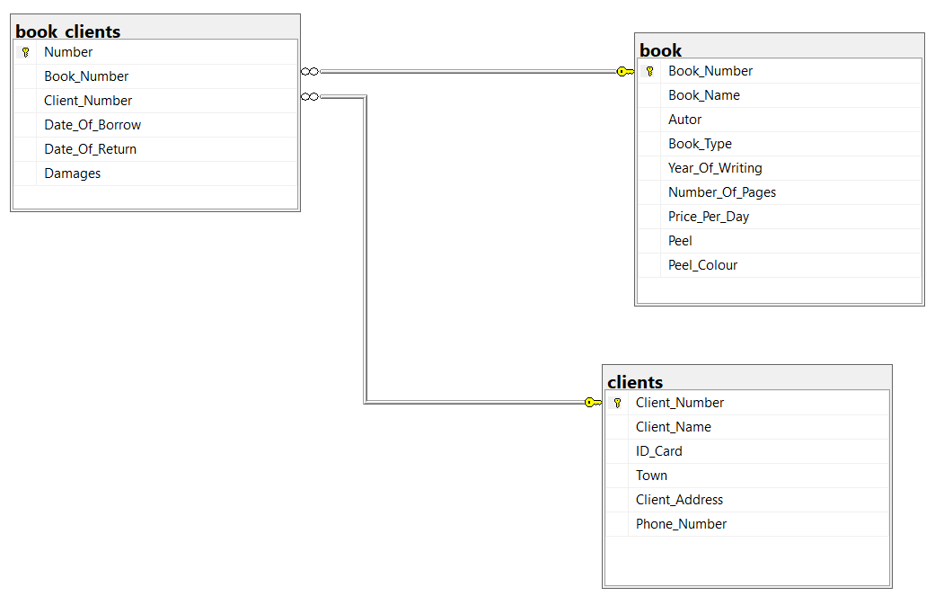

## 4 . Realization of the relationship model of the database

-- Createa book (Books)

CREATE TABLE book (

Book_Number int PRIMARY KEY IDENTITY (1,1),

Book_Name varchar (30) NOT NULL,

Autor varchar (30) NOT NULL,

Book_Type varchar (30) NOT NULL,

Year_Of_Writing INT NOT NULL,

Number_Of_Pages INT NOT NULL,

Price_Per_Day MONEY NOT NULL,

Peel varchar (20) NOT NULL,

Peel_Colour varchar (20) NOT NULL

)

-- Filledin on the data "book" table

INSERT INTO book (Book_Name,Autor,Book_Type,Year_Of_Writing,Number_Of_Pages,Price_Per_Day,Peel,Peel_Colour)

VALUES ("Under theIgo," "Ivan Vazov," "novel," 1894, 431, 3, "hard cover," "red"),

("1885, 128, 5, "hard cover", "green"),

("Tobacco", "Dimitar Dimov", "novel",1951, 616, 2, "soft cover","green"),

("The Iron Lamp" , "Dimitar Talev" , "roman",1954, 338, 3, "soft cover","green"),

("The Prespa Bells," "Dimitar Talev," "Roman," 1954, 486, 4, "trda cover," "yellow"),

('Bai Gaño', 'Aleko Konstantinov', 'narrative', 1895, 176, 4, 'soft cover', 'red'),

("To Chicago and Back," "Aleko Konstantinov," "novel," 1894, 120, 2, "soft cover," "red")

-- Create the"clients" table

CREATE TABLE clients (

Client_Number int PRIMARY KEY IDENTITY (1,1),

Client_Name varchar (80) NOT NULL,

ID_Card INT NOT NULL,

Town varchar (40) NOT NULL,

Client_Address varchar (80) NOT NULL,

Phone_Number varchar (50) NOT NULL

)

-- Filledin on the table "clients" with data

INSERT INTO clients (Client_Name, ID_Card, Town, Client_Address, Phone_Number)

VALUES ("Stefan Marinov", 582179286, "Varna", "Brothers Miladinovi Str." No1","0895/465-345"),

("Stefani Todorova", 986729123, "Plovdiv", "Street". 9,'0893/312-561',

("Petar Ivanov", 771354361, "Veliko Tarnovo", "Blvd." 22 Nikola Gabrovski Str., '0894/111-222'),

("Nikola Zhekov", 954897653, "Varna", "Ul." 5,'0899/465-345',

("Ivan Valentinov", 911852041, "Sofia", "Blvd." 1,'0892/483-859',

("Asparus Nicodemov", 801857093, "Plovdiv", "Ul." 77 Vasil Levski Str., '0878/345-999'),

("Ivaylo Shopov", 756349719, "Sofia", "Ul." 4,0894/532-112')

-- Creating the "book_clients" (Book Clients)

CREATE TABLE book_clients(

Number int PRIMARY KEY IDENTITY(1,1),

Book_Number INT NOT NULL,

Client_Number INT NOT NULL,

Date_Of_Borrow DATE NOT NULL,

Date_Of_Return DATE NOT NULL,

Damages varchar(50) NOT NULL

)

-- Filledin on the table "book_clients" with data

INSERT INTO book_clients (Book_Number,Client_Number,Date_Of_Borrow,Date_Of_Return,Damages)

VALUES (1,1, '2022-03-21', '2022-03-23', 'no damage'),

(7,2,'2022-03-25','2022-04-02','no damage'),

(4,5,'2022-02-26','2022-03-02','no damage'),

(3,7,'2022-03-20','2022-03-22','there are damage'),

(2,4,'2022-03-01','2022-03-02','no damage'),

(5,3,'2022-03-25','2022-03-02','there are damage'),

(6,6,'2022-03-25','2022-03-02','there are damage')

## 5. Create queries

-- Query that displays the order by age and removes recurrences

SELECT DISTINCT Year_Of_Writing

FROM book

-- Query that displays the information from the three columns arranged by number

SELECT Client_Number, ID_Card, Town

FROM clients

ORDER BY Client_Number

-- A query that displays the names of customers who start with the letter "I" and their phone number

SELECT Client_Name, Phone_Number

FROM clients

WHERE Client_Name LIKE 'And%'

-- A request that displays all the information about the customers and books that have been taken

SELECT book.*, clients.*

FROM clients, book_clients, book

WHERE book. Book_Number = book_clients. Book_Number AND /connection between

clients. Client_Number = book_clients. Client_Number primary keys/

-- A request that shows the name and phone of customers who have taken a book more expensive than 3 BGN per day

SELECT Client_Name, Phone_Number

FROM clients, book_clients, book

WHERE book. Book_Number = book_clients. Book_Number AND

clients. Client_Number = book_clients. Client_Number AND

Price_Per_Day > 3

-- Query that groups books by author and creates a new column showing the number of books by that author in the table

SELECT Autor, COUNT(*) AS [Number of books] FROM book

GROUP BY Autor

HAVING Autor = 'Ivan Vazov';

## 6. Establishment of the necessary:

- views:

-- Create a view that displays the names of all books written after 1900.

CREATE VIEW [BooksAfter1900] AS

SELECT Book_Name, Year_Of_Writing

FROM book

WHERE Year_Of_Writing > 1900;

-check

SELECT* FROM BooksAfter1900

- stored procedures and/or user defined functions:

-- Create a procedure that displays all books that, for a particular type of

CREATE PROCEDURE SelectAllBook @Book_Type varchar(30)

AS

SELECT * FROM book WHERE Book_Type = @Book_Type

GO

-check

EXEC SelectAllBook @Book_Type = 'novel';

- triggers:

-- Trigger that disables the deletion of customers from the table containing user data

CREATE TRIGGER No_DeleteClients

ON clients

INSTEAD OF DELETE

AS

IF @@ROWCOUNT = 0 RETURN

RAISERROR('Deleting rows in the table is not allowed.' , 8, 1);

-check

DELETE clients

WHERE Client_Number = 1

## 7. Future work

Future improvements would also include implementing a book-buying option. The possibility of home delivery can be added. The database could be used as a basis for the development of a web application for the sale of books in electronic form.